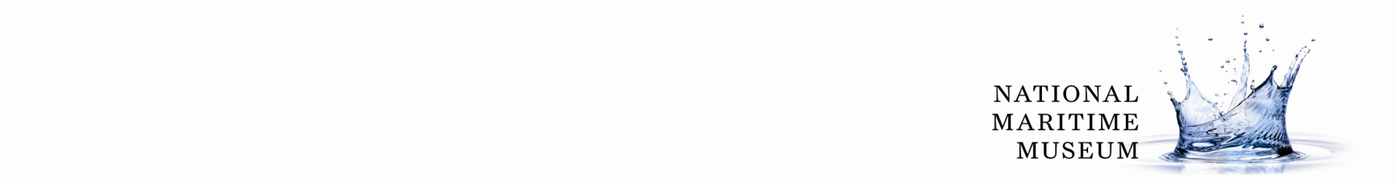
Frequently Asked Questions (FAQs) for People Who Wish to Give or Sell Items to the National Maritime Museum (NMM)

Definitions
- ‘Objects’ is a blanket term that includes manuscripts and other flat items as well as 3D artefacts.
- The terms ‘object’, ‘item’ and ‘artefact’ are interchangeable for the purposes of this document.
- ‘Collection’ means all the objects in the care of the National Maritime Museum (NMM).

Disclaimer
The NMM collection is held in trust on behalf of the nation, for the benefit of present and future generations. NMM is the legal owner of the collection in name only: the collection belongs to the British public and NMM is merely its guardian. The contents of this document are for guidance only and are not legally binding on any party.

FAQs

Q1) Will the National Maritime Museum be interested in having my object/s?
A1) Possibly, but we receive a lot of offers so we will need to think about it very carefully.

Q2) What kind of objects does the NMM collect?
A2) The NMM is mainly interested in nationally or internationally significant objects, or objects that are the finest examples of their type within our given subject areas of the sea, ships and stars, and their relationship with people. These include but are not limited to fine art, timekeeping, scientific instruments, ship plans and models, weapons and equipment, textiles, globes and charts, and rare books and manuscripts.

Q3) If not the NMM, are there any other museums that might be interested?
A4) We will be able to recommend other institutions if we think your object is not suitable for us.

Q4) What are the methods of offering objects?
A4) We need to know from the outset how you intend to offer your object. There are 4 basic options: gift, bequest, sale or loan (N.B. we only accept loans in exceptional circumstances).

Q5) How do I make an offer?
A5) Please send us an e-mail or letter telling us about your object, including digital photographs . The contact details are given at the end of this document.

Q6) I’m not sure who actually owns the object - do you accept offers in good faith?
A6) We cannot accept any new acquisition without some evidence of previous ownership. Where none is available a written statement to that effect may be acceptable.

Q7) Can I send or bring my object in to you?
A7) Please keep hold of your object for the time being. We will get in touch with you if we need to see it in person.

Q8) Will you be able to tell me how much the object is worth?
A8) We can offer expert opinions on the cultural, historical or scientific interest of objects. We cannot give a monetary value. Please contact an auctioneers or valuers for a monetary valuation

Q9) How does the museum decide which objects to accept for the collection?
A9) The NMM has a formal decision-making procedure. Once all the information is gathered if the relevant Curator wishes to acquire this object for NMM then it will be submitted to the Collections Development Committee, who meet once a month. We receive over 500 offers a year.

Q10) How soon can you let me know?
A10) We aim to turn around offers to acquire objects within twelve working weeks.

Q11) Can I attach conditions to my gift?
A11) The NMM tries to avoid accepting gifts that come with conditions attached.

Q12) What is the legal mechanism for transferring property?
A12) This differs from case to case depending on how the object is offered. For gifts, we ask donors to fill in and return our ‘Transfer of Title’ form. With sales, legal transfer occurs when money changes hands.

Q13) Who retains the intellectual property rights (IPR)?
A13) We ask that any and all intellectual property rights be transferred to the NMM along with title to the object. This is to increase the accessibility of the object (through Collections Online) and to maximise the publishing and licensing potential of our collections. We also want to ‘future-proof’ the rights in order to be able to take advantage of any potential technical advances.

Q14) Where can I get further information?
A14) The topics covered in this document are discussed in more depth in our ‘Guidance for Donors’ document. Alternatively, members of staff in the NMM Registration Section are always happy to discuss any of the issues raised here. Please contact,

Assistant Collections and Loans Registrar
National Maritime Museum
Park Row
Greenwich
London SE10 9NF
Email: Registration@rmg.co.uk

Tel. 020 8312 6624

